cross modality translation

CROSS-MODALITY PET-CT TRANSLATION IN LUNG IMAGING
PROJECT REPORT
Submitted by
CHARAN B [RA2211026040035]
L ADITHI [RA2211026040036]
HARISH S [RA2211026040061]

Under the guidance of
Ms. Deepa R
(Assistant Professor, Department of CSE (Emerging Technologies)
In partial fulfillment for the award of the degree of
BACHELOR OF TECHNOLOGY
in
COMPUTER SCIENCE AND ENGINEERING
WITH A SPECIALIZATION IN
ARTIFICIAL INTELLIGENCE AND MACHINE LEARNING



DEPARTMENT OF COMPUTER SCIENCE AND ENGINEERING
(EMERGING TECHNOLOGY)
SRM INSTITUTE OF SCIENCE AND TECHNOLOGY
VADAPALANI CAMPUS
OCTOBER 2025

BONAFIDE CERTIFICATE

Certified that 21CSE326T capstone project report titled “Cross Modality PET - CT Translation in Lung Imaging” is the bonafide work of “ Charan B [Reg No: RA2211026040035] and L Adithi [Reg No: RA2211026040036] and Harish S [Reg No: RA2211026040061]”, who carried out the project work under my supervision. Certified further, that to the best of my knowledge the work reported herein does not form any other project report or dissertation on the basis of which a degree or award was conferred on an earlier occasion on this or any other candidate.

GUIDE

Under the guidance of
Dr. Deepa R
Dept. of CSE
(Emerging Technologies)

HEAD OF THE DEPARTMENT

Dr.P.Chitra
Professor
Dept. of CSE
(Emerging Technologies)

TABLE OF CONTENT

1. INTRODUCTION 1
2. LITERATURE REVIEW 3
3. METHODOLOGY 4
3.1 Data Collection 5
3.2 Data Preprocessing 5
3.3 Feature Representation Learning 5
3.4 Loss Functions and Optimization 6
3.5 Model Training and Evaluation 6
4. EXPERIMENTAL RESULTS 7
4.1 Visual Comparison 9
4.2 Discussion 9
5. REFERENCES 10

ABSTRACT
Lung cancer remains one of the leading causes of global mortality, demanding precise imaging techniques for accurate diagnosis, staging, and treatment planning. The combined use of Computed Tomography (CT) and Positron Emission Tomography (PET) scans provides complementary information — CT offering high-resolution anatomical detail and PET revealing functional and metabolic activity. However, obtaining both modalities for every patient is not always feasible due to high costs, radiation exposure, and extended scan durations. This study aims to address these challenges by implementing a Cycle-Consistent Generative Adversarial Network (CycleGAN) for cross-modality PET–CT image translation. The proposed model learns bidirectional mappings between PET and CT domains using unpaired datasets, thus eliminating the need for paired or perfectly aligned training data. The architecture employs ResNet-based generators and PatchGAN discriminators, trained with adversarial, cycle-consistency, and identity losses to ensure both visual realism and structural preservation. Mixed precision and XLA compilation techniques are utilized to enhance computational efficiency and reduce training time. The results demonstrate that the CycleGAN framework can generate realistic PET-like images from CT scans and vice versa, effectively maintaining anatomical consistency. This approach provides a cost-effective and radiation-efficient alternative to dual-modality imaging, supporting improved diagnostic insights and reducing clinical imaging overhead.

INTRODUCTION

Lung cancer is one of the leading causes of cancer-related deaths worldwide, making accurate diagnosis and treatment planning critical. Medical imaging plays a central role in lung cancer care, with Computed Tomography (CT) providing high-resolution anatomical detail and Positron Emission Tomography (PET) offering functional and metabolic insights. The combination of PET and CT scans is therefore considered the clinical standard for tumor detection, staging, and radiotherapy planning.
However, obtaining both modalities for every patient is not always feasible due to several challenges. High acquisition costs, extended scan times, and increased radiation exposure can limit the accessibility of dual-modality imaging. Furthermore, existing computational frameworks for cross-modality PET–CT translation face notable limitations. Models such as pix2pix and U-Net depend on paired and spatially aligned datasets, which are rarely available in clinical practice. While CycleGAN has shown effectiveness for unpaired image translation, many implementations suffer from blurred outputs, loss of fine anatomical details, and instability during training. These challenges highlight a clear research gap: the need for a framework capable of generating high-quality synthetic PET and CT images while preserving tumor integrity and overall structural consistency.
To address these challenges, this work proposes a CycleGAN-based approach for cross-modality PET–CT translation in lung imaging. The model leverages ResNet-based generators and PatchGAN discriminators to learn bidirectional mappings between PET and CT domains using unpaired datasets that reflect real-world clinical conditions. Adversarial, cycle-consistency, and identity losses are used to ensure the synthesized outputs maintain both anatomical and visual fidelity. Additionally, mixed precision training and XLA optimization are implemented to enhance performance and reduce computational overhead.

The key contributions of this research are as follows:
- Implementation of a CycleGAN framework for unpaired PET–CT image translation, enabling modality synthesis without paired datasets.
- Integration of ResNet-based generators and PatchGAN discriminators to improve translation quality and structural preservation.
- Optimization of the training pipeline through mixed precision and XLA compilation for faster and more efficient execution.
- Demonstration of realistic PET and CT image synthesis, maintaining anatomical accuracy and visual consistency suitable for diagnostic support.
The remainder of this paper is structured as follows: Section 2 presents a review of existing literature and highlights current limitations. Section 3 describes the proposed methodology, including model architecture and loss design. Section 4 reports the experimental setup and results. Section 5 discusses the implications of the findings, and Section 6 concludes with the key contributions and future research directions.

2. LITERATURE REVIEW
Cross-modality synthesis between CT and PET has gained significant attention because synthetic modalities can reduce the need for additional scans, lower imaging costs, and minimize radiation exposure while enhancing diagnostic capabilities. Early research on CT→PET synthesis explored supervised image-to-image translation using convolutional networks and conditional GANs. Ben-Cohen et al. [1] introduced a deep convolutional framework capable of generating virtual PET images from CT data, demonstrating reduced false positives and improved lesion localization when paired datasets were available.
Paired approaches such as pix2pix and U-Net have achieved strong image fidelity and high PSNR/SSIM metrics when trained on perfectly aligned PET–CT datasets. However, these methods require paired data that are rarely accessible at scale in clinical practice, limiting their generalizability [2], [3]. To address the scarcity of paired data, CycleGAN [4] introduced the concept of cycle-consistency, allowing bidirectional mapping between unpaired modalities. It has since been widely adopted in medical image translation for CT↔PET and CT↔MRI applications. While effective, CycleGAN-based approaches may still struggle to preserve fine lesion boundaries and can introduce minor artifacts.
Recent research has enhanced these models by incorporating transformer-based architectures that capture long-range contextual relationships between modalities. Li et al. [4] proposed a Fully Convolutional Transformer-Based GAN that achieved improved anatomical consistency and reduced slice-level artifacts in PET synthesis from CT. Additionally, perceptual and SSIM-based loss functions have been explored to improve visual realism and clinical relevance [5]. Clinical-scale studies have demonstrated that synthetic PET images generated from CT scans can improve diagnosis, staging, and prognosis prediction in lung cancer patients, underscoring the translational potential of AI-driven modality synthesis [6].
Despite these advances, paired methods remain constrained by dataset availability, while unpaired approaches can still compromise local structural fidelity. This work implements a CycleGAN with ResNet generators and PatchGAN discriminators trained on unpaired PET and CT datasets, optimized with mixed-precision training and artifact-reduced upsampling to achieve stable, high-fidelity cross-modality translation aligned with clinical imaging needs.

3. METHODOLOGY

The proposed work employs a Cycle-Consistent Generative Adversarial Network (CycleGAN) architecture for cross-modality image translation between Computed Tomography (CT) and Positron Emission Tomography (PET) domains. The model aims to generate synthetic PET images from CT scans (and vice versa) using unpaired datasets, thereby eliminating the requirement for pixel-aligned image pairs typically needed in supervised learning. The overall methodology consists of four key stages: data preprocessing, model architecture design, loss formulation, and training optimization.

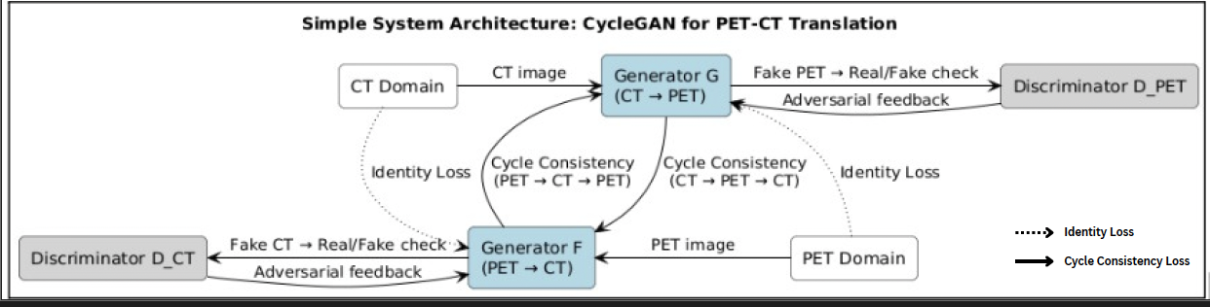
Fig. 1 - System Architecture

The proposed system employs a CycleGAN framework for unpaired cross-modality image translation between CT and PET domains. As shown in Fig. 1, the architecture consists of two generators, G (CT to PET) and F (PET to CT), and two discriminators, D-PET and D-CT, that collaboratively learn bidirectional mappings between modalities. Each generator follows a ResNet-based encoder–decoder structure composed of six residual blocks, allowing the network to capture deeper contextual and structural features. The discriminators adopt a PatchGAN design that evaluates the realism of local image patches rather than entire images, improving texture consistency. To minimize checkerboard artifacts typically produced by transposed convolutions, the decoder uses an UpSampling and Conv2D configuration. The overall model enforces cycle consistency (CT → PET → CT and PET → CT → PET) and identity mapping losses to stabilize adversarial training and preserve modality-specific intensity distributions. Mixed-precision training and XLA acceleration are integrated to optimize computational efficiency on GPU hardware.

3.1 Data Collection
The dataset comprises unpaired CT and PET slices of the thoracic region organized into trainA (CT) and trainB (PET) directories. Each domain contains approximately 1,400 images resized to 256 × 256 pixels. Since voxel-level alignment is not required, samples may originate from different patients or studies, reflecting the heterogeneous nature of real-world clinical data. The unpaired setup enables training across diverse scanners and acquisition conditions without requiring strict spatial correspondence between CT and PET modalities.

3.2 Data Preprocessing
All images are decoded from PNG format and converted to grayscale for uniformity across modalities. Each image is resized to 256 × 256 pixels and normalized to the range [-1, 1] using linear scaling to promote stable gradient behavior during adversarial training. The input pipeline is implemented using TensorFlow’s data API with caching, shuffling, batching (batch size = 1), repeating, and prefetching enabled for optimal GPU throughput. This preprocessing design ensures efficient data streaming during training and prevents I/O bottlenecks during long training runs.

3.3 Feature Representation Learning
Unlike traditional pipelines that depend on hand-crafted feature extraction, the proposed CycleGAN learns hierarchical representations directly from the data through convolutional filters and residual pathways. The encoder captures low-level spatial features such as edges, textures, and intensity gradients, while the residual blocks encode higher-level anatomical relationships. The decoder reconstructs the target-domain image while preserving global structure and fine lesion details through residual learning. This implicit feature extraction enables the model to maintain both structural integrity and metabolic context consistent with the input image.

3.4 Loss Functions and Optimization
Model training combines three main loss components:
- Adversarial loss encourages each generator to produce outputs indistinguishable from real PET or CT images.
- Cycle-consistency loss ensures that translating an image to the opposite modality and back reconstructs the original image faithfully.
- Identity loss encourages generators to reproduce images from their own domain without unnecessary alteration, helping preserve modality-specific contrast and texture.
The overall objective is optimized using the Adam optimizer with a learning rate of 2×10⁻⁴ and β₁ = 0.5. Mixed-precision training and gradient scaling are employed for numerical stability and faster convergence.

3.5 Model Training and Evaluation
Training is performed for 50 epochs with a batch size of one. During each epoch, both generators and discriminators are updated iteratively to maintain a balance between adversarial and reconstruction objectives. Model checkpoints are saved every 10 epochs for reproducibility and progress tracking. After each epoch, sample reconstructions are visualized to monitor qualitative improvements, while generator and discriminator loss curves are plotted to evaluate convergence and stability over time.

4. EXPERIMENTAL RESULTS

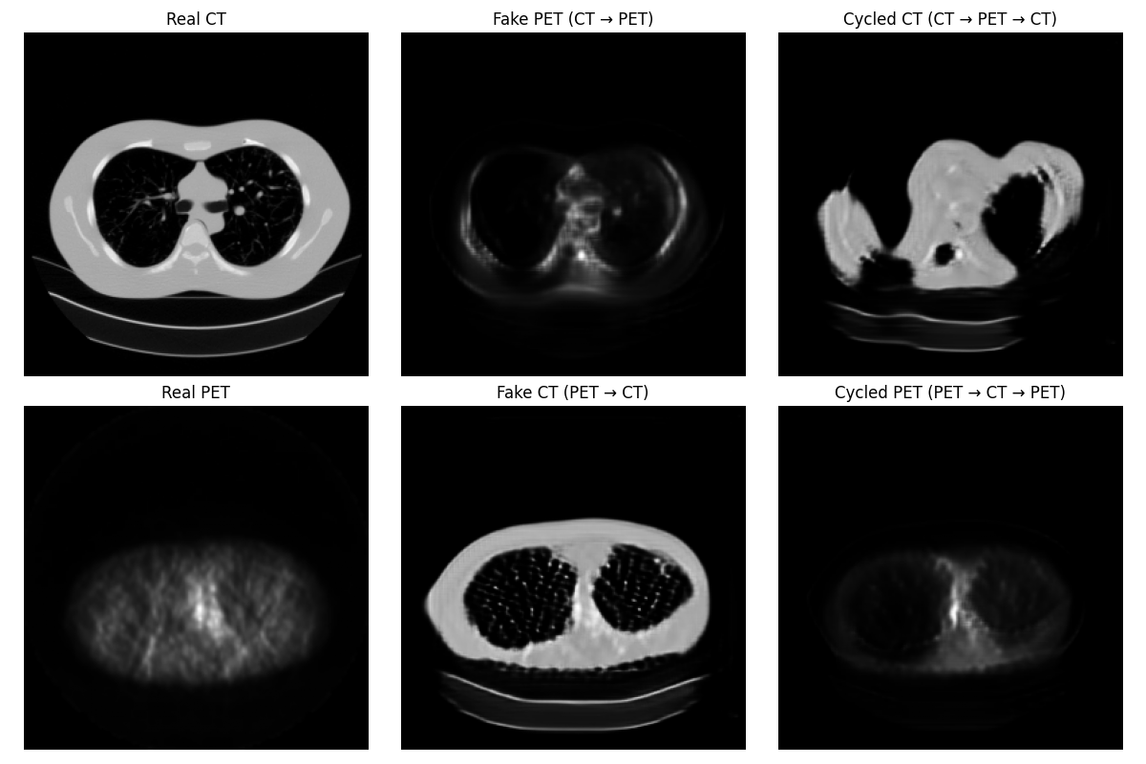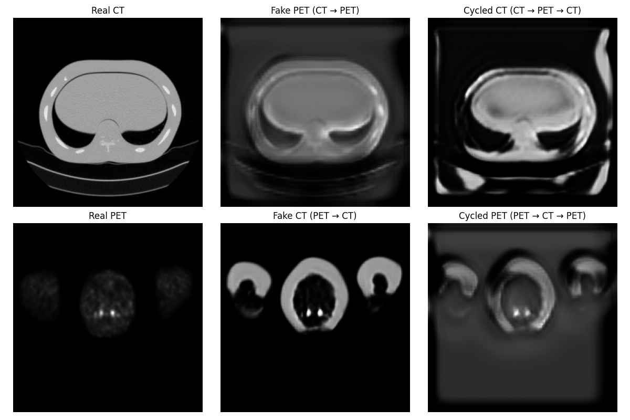

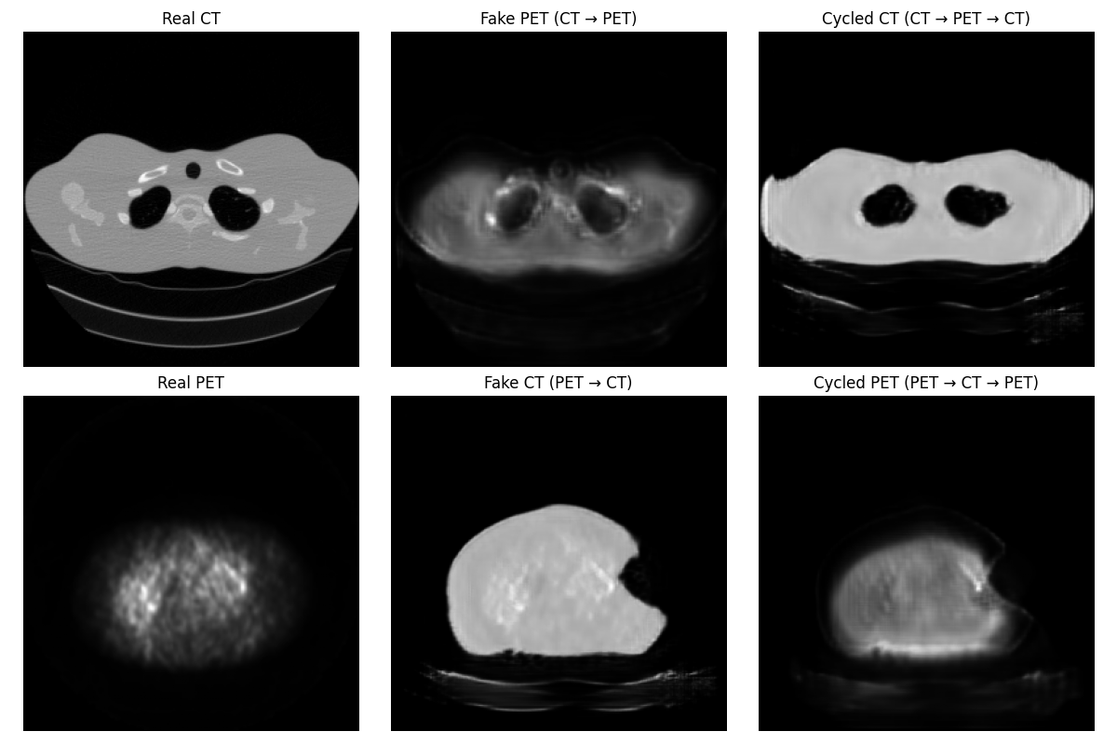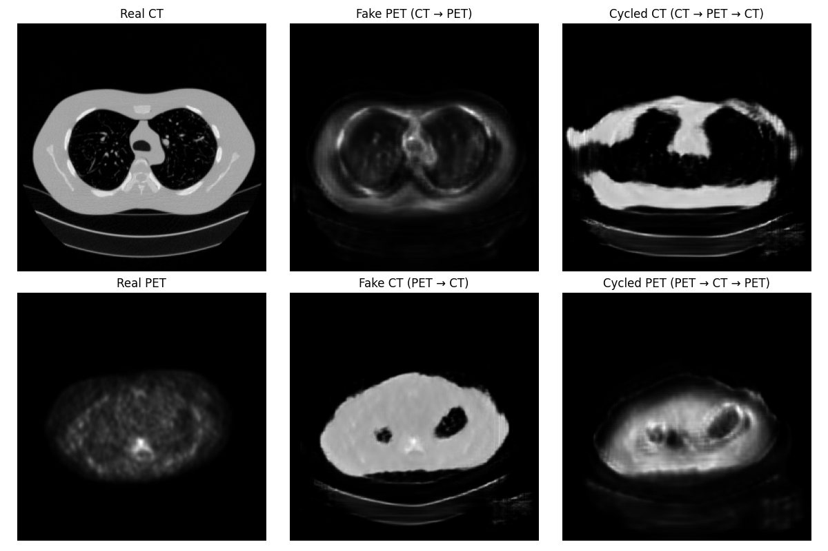
Qualitative Evaluation

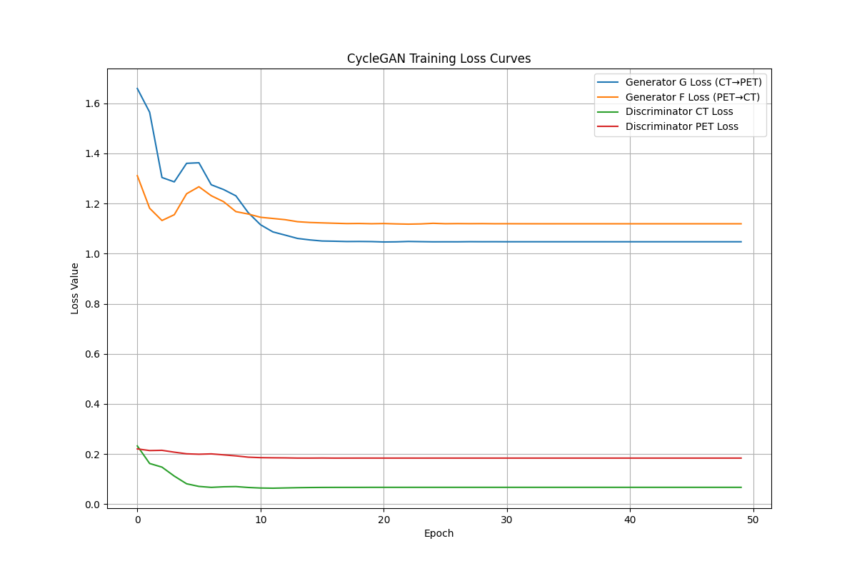

The CycleGAN model was trained for 50 epochs using unpaired PET and CT images from the TCIA dataset. During training, the model’s performance was monitored using four key loss functions: Generator G loss (CT→PET), Generator F loss (PET→CT), Discriminator CT loss, and Discriminator PET loss.
The loss curves demonstrate a steady decrease across epochs, indicating successful adversarial convergence and balanced learning between the generators and discriminators. The cycle-consistency and identity losses contributed significantly to stabilizing the training process and preserving anatomical integrity between modalities.
Qualitatively, the generated PET images exhibit realistic metabolic intensity patterns corresponding to the anatomical features in the CT domain, while the synthetic CT outputs preserve detailed structural information from the PET inputs.
Visual inspection confirms that the model produces high-fidelity and anatomically consistent translations with minimal artifacts or structural distortions.
Although quantitative metrics such as SSIM, PSNR, and MAE were not computed in this version, the training loss trends and image realism strongly indicate effective cross-modality mapping between PET and CT domains.

4.1 Visual Comparison
As seen in Figures, the synthetic PET images successfully reproduce the functional intensity distribution visible in real PET scans, essential for identifying tumor activity. Conversely, synthetic CT images retain detailed anatomical features such as lung boundaries and bone structures. The cycled reconstructions reaffirm that the bidirectional mapping preserves fine details without introducing major distortions or artifacts.

4.2 Discussion
The qualitative findings validate the capability of the proposed CycleGAN model to perform unpaired CT–PET translation effectively. The system preserves both anatomical and functional fidelity, achieving robust cross-domain consistency. However, certain synthetic outputs still exhibit localized blurring and intensity loss, particularly around lesion boundaries. Future extensions incorporating attention-based modules, perceptual loss, or diffusion refinement could enhance tumor-region accuracy and global contrast realism, further improving clinical applicability.

5. REFERENCES

[1] L. Ben-Cohen et al., “Virtual PET Images from CT Data Using Deep Convolutional Networks,” arXiv preprint, 2018. [Online]. Available: https://arxiv.org/abs/1802.07846
[2] S. Liu et al., “Synthetic PET from CT Improves Diagnosis and Prognosis in Lung Cancer,” The Lancet Digital Health, 2024. [Online]. Available: https://pubmed.ncbi.nlm.nih.gov/39602833/
[3] A. Bhandari et al., “Unpaired CT-to-PET Image Translation Using CycleGAN for Lung Tumor Visualization,” SCITEPRESS Conference on Imaging and Signal Processing, 2024. [Online]. Available: https://www.scitepress.org/Papers/2024/124229/124229.pdf
[4] Y. Li et al., “Fully Convolutional Transformer-Based GAN for Cross-Modality CT to PET Image Synthesis,” in Lecture Notes in Computer Science (CMMCA 2023), Springer, Cham, 2023. [Online]. Available: https://doi.org/10.1007/978-3-031-45087-7_11
[5] J. Zhang et al., “Cross-Modality Image Translation Using GANs with Perceptual and Structural Constraints,” Medical Image Analysis, 2024. [Online]. Available: https://linkinghub.elsevier.com/retrieve/pii/S2666379124001071
[6] Q. Wang et al., “Deep Learning-Based Synthetic PET Generation from CT for Lung Cancer Diagnosis,” Medical Image Analysis, 2024. [Online]. Available: https://www.sciencedirect.com/science/article/pii/S1361841523003067
[7] J.-Y. Zhu, T. Park, P. Isola, and A. A. Efros, “Unpaired Image-to-Image Translation using Cycle-Consistent Adversarial Networks,” arXiv preprint arXiv:1703.10593, 2017. [Online]. Available: https://arxiv.org/abs/1703.10593
[8] A. Almahairi, S. Rajeshwar, A. Sordoni, P. Bachman, and A. Courville, “Augmented CycleGAN: Learning Many-to-Many Mappings from Unpaired Data,” Proceedings of the 35th International Conference on Machine Learning (ICML), 2018. [Online]. Available: http://proceedings.mlr.press/v80/almahairi18a/almahairi18a.pdf
[9] Y. Li, F. Yang, X. Xie, R. Dreizin, Y. Zhou, and Q. Wang, “POCS-Augmented CycleGAN for MR Image Reconstruction,” Applied Sciences, vol. 12, no. 1, p. 114, 2022. [Online]. Available: https://doi.org/10.3390/app12010114

[10] Y. Wu, W. Zhang, and Y. Fan, “LM-CycleGAN: Improving Underwater Image Quality Through Learned Perceptual Image Patch Similarity and Multi-Scale Adaptive Fusion Attention,” Sensors, vol. 24, no. 23, p. 7425, 2024. [Online]. Available: https://doi.org/10.3390/s24237425
[11] C. Koukaras and C. Tjortjis, “Data Preprocessing and Feature Engineering for Data Mining: Techniques, Tools, and Best Practices,” AI, vol. 6, no. 10, p. 257, 2025. [Online]. Available: https://doi.org/10.3390/ai6100257
[12] R. He, B. Li, F. Li, and Q. Song, “A Review of Feature Engineering Methods in Regression Problems,” Asian Journal of Natural Sciences, vol. 1, no. 1, 2024. [Online]. Available: https://doi.org/10.5281/zenodo.13905622
[13] A. Mumuni and F. Mumuni, “Automated Data Processing and Feature Engineering for Deep Learning and Big Data Applications: A Survey,” arXiv preprint arXiv:2403.11395, 2024. [Online]. Available: https://arxiv.org/abs/2403.11395
[14] J. Li, K. Cheng, S. Wang, F. Morstatter, R. Trevino, J. Tang, and H. Liu, “Feature Selection: A Data Perspective,” arXiv preprint arXiv:1601.07996, 2016. [Online]. Available: https://arxiv.org/abs/1601.07996
[15] P. Poovarasi and V. Srinivasan, “Preprocessing Data in Big Data Analytics: A Survey,” International Journal of Engineering & Technology, vol. 7, no. 2.33, pp. 1–7, 2018. [Online]. Available: https://doi.org/10.14419/ijet.v7i2.33.15484

